NUCLEIC ACIDS AND THE GENETIC CODE.
Nucleic acids include; Deoxyribonucleic acid (DNA) and Ribonucleic acid (RNA)
The building blocks of nucleic acids are known nucleotides
The structure of nucleotides
Nuclei acids are made up of many nucleotides
Individual nucleotides comprise 3 parts
1. Phosphoric acid (phosphate group H₃P O₄). This has the same structure in all nucleotides in both RNA and DNA.
2. Pentose sugar. Two types occur ie the ribose sugar (C₅ H₁₀ O₅) which is identical in all RNA molecules and the Deoxyribose sugar (C5 H₁₀ O₄) which is also identical in all DNA molecules
3. Organic base. There are 5 different bases divided into 2 groups ie
a) Pyrimidines- Have single rings each with 6 sides (hexagonal ring). They include cytosine (C), thymine (T) and Uracil (U)
b) Purines- have double rings where 1 is 6 sided (hexagonal ring) joined to the second ring is 5 sided (pentagonal ring). These Adenine (A) and Guanine (G)
Purines bases can only be linked to pyrimidines.
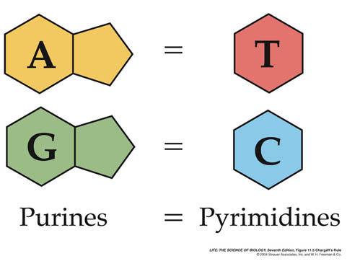The 3 components (phosphoric acid, pentose sugar and organic base) are combined by condensation to form a nucleotide
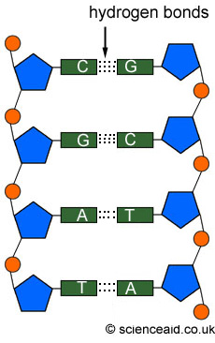
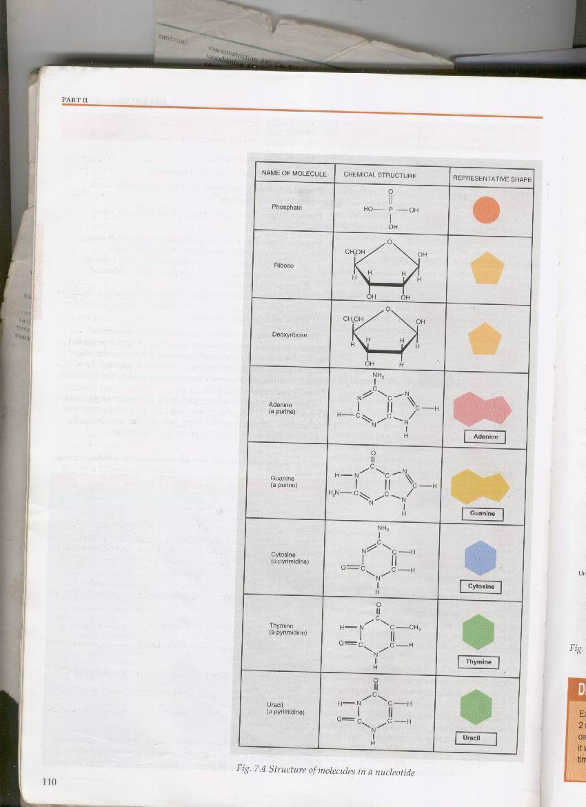
WRITE DOWN THE ILLUSTRATION (FIG 30.1) TO SHOW THE PROCESS OF CONDENSATION (FUNCTIONAL APPROACH PAGE 482)
During the process of condensation a sugar ring attaches itself to a phosphoric acid molecule at position 5, and to one of the five bases at position 1. Two molecules of water are removed in this process.
By similar condensation between sugar and phosphate groups of two nucleotides, a dinucleotide is formed. Continued condensation reactions leads to a polynucleotide.
The main function of nucleotides is to form nucleic acids (RNA and DNA) which play vital roles in protein synthesis and heredity.
DEOXYRIBONUCLEIC ACID (DNA)
DNA is a double stranded polymer of nucleotides where the Pentose sugar is Deoxyribose and the organic bases are Guanine, Cytosine, Adenine and Thymine but never Uracil. Each of these polynucleotide chains is extremely long and consists of millions of nucleotides.
The mount of Guanine = to Cytosine and the amount of Adenine = to thymine
There fore; G binds to/pairs with C and A binds to/ pairs with T by formation of Hydrogen-bonds following the complementary base pairing rule.
The sequence in which these bases occur along the length of the nucleic acid chain varies from species to species and from individuals to individuals hence leading to variation among organisms.
It’s in this sequence of bases that the nuclei acid carries information responsible for all the traits of an organism.
Watson-crick hypothesis 1953
They put forward a possible structure of the DNA molecule.
By use of X-ray patterns, they came to a conclusion that DNA molecule consists of 2 parallel chains twisted to form a double helix. From the relative positions of certain spots in the X-ray photographs, they concluded that the two chains are cross linked at regular intervals corresponding to the nucleotides and that there are ten nucleotides for one complete turn of the helix.
They also stated that DNA is a kind of twisted ladder, the 2 uprights consisting of chains of alternating sugar and phosphate groups, the rungs as pair of bases sticking in wards towards each other and linked up in a specific relation ship A-T and G-C.
The rungs in the DNA ladder can only be formed by linking purine with pyrimidine bases because according to their relative sizes, there would be insufficient room for two purines to link and too much room for two pyrimidines.

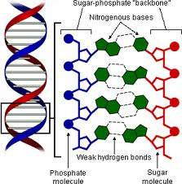
DNA replication:
This is the process by which DNA makes an exact copy if its self. This ensures that genetic information is transmitted from cell to cell and from generation to generation. (Refer to the cell cycle)
The process of DNA replication
According to Watson and crick, DNA replication starts with un zipping of the Double helix (un winding of the two strands and separating of the two strands (due to the breaking of the weak hydrogen bonds between the complementary bases) so that each strand acts as a template to which the complementary sets of nucleotide will attach by base pairing rule.
The process of un zipping of the double helix and attachment of the complementary sets of nucleotide to the template strand following the base pairing rule is catalyzed enzyme DNA polymerase.
There fore; each DNA molecule will give rise to two identical copies of DNA.
NB: DNA polymerase adds nucleotides to the strand running in the 5’ to 3’ direction and since the 2 DNA strands lie in opposite directions, DNA polymerase can continuously produce one new DNA strand at a time. Short segments of the other DNA molecule are produced by the action of DNA polymerase moving in the opposite direction. These short sections of the newly synthesized polynucleotide chains are joined to together by the action of enzyme DNA ligase

Semi-conservative Vs Conservative DNA replication
The zip-fastener idea is a neat and economical way of explaining replication but its not the only one. An alternative hypothesis is to suppose that the double helix remains intact and in some way stimulates the synthesis of a second double helix identical with the first as explained below
Semi-conservative is where each new double helix retains one strand of the original double helix i.e one new strand and one old strand (crick and Watson (zip-fastener-idea)).
Conservative is where an entire new double helix is formed alongside the original parent
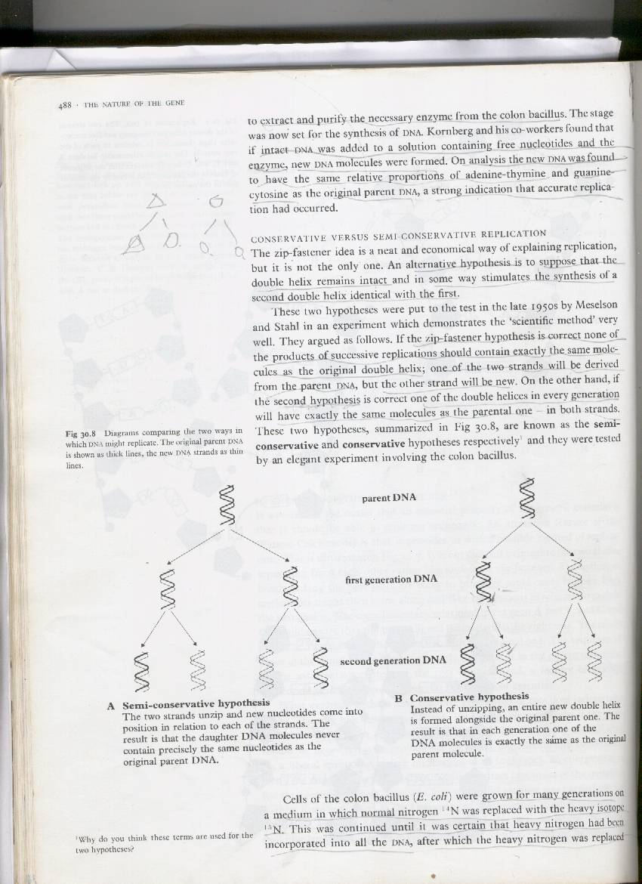

The evidence of semi-conservative replication was provided by meselsohn and stahl.
E.coli was grown for many generation in a medium in which normal ¹⁴ N was replaced by heavy isotope ¹⁵ N
Heavy isotope was integrated into all the bacterial DNA (Grew E. coli in ¹⁵N for several generations so that all the DNA was labeled)
They shifted cells to 14N media and allowed them to replicate their DNA 1 time
Sample of DNA was taken.
Cells were allowed to replicate their DNA again (total of 2 times) Sample of DNA was taken
Used a special centrifugation of DNA samples to determine the isotope composition and pattern of labeling in the DNA à found pattern matched semi-conservative
Ribonucleic acid; RNA
RNA is a single –stranded polymer of nucleotides where the pentose sugar is always ribose and the organic bases are ever Adenine, Guanine, Cytosine and Uracil but never thymine. A pairs with U and G pairs with C.
There are3 types of RNA are found in cells and all of them are involved in the process of protein synthesis.
All types are synthesized directly on DNA which acts as a template for RNA production
1. Ribosomal RNA (rRNA)
First type to be discovered and it makes 80% of the total RNA in the cell
Its synthesized by DNA genes found with in a region of the nucleolus known as nucleolar organizer
The base sequence of rRNA is similar in all organisms from bacteria to higher plants and animals.
Its found in the cytoplasm where its associated with a protein molecule, which together form ribosomes
2. Transfer RNA: tRNA/soluble RNA: sRNA
It’s a small single stranded molecule made up of about 80nucleotides.(it’s the smallest of all RNAs)
Its manufactured by nuclear DNA. Makes about 10-15% of the total RNA in the cell
It forms a clover leaf shape with one end (3’) of the chain ending into C, C, A sequence, and its where an Amino-acid attaches its self and the other end (5’) always ends with the base G . Each amino acid is attached to its specific tRNA by its own form of the enzyme amino-acyl-tRNA synthetase. This will result into an amino-acid tRNA complex with sufficient energy in the bond between the terminal nucleotide A (of the CCA) with the amino acid.
About 20 types of tRNA have been identified each carrying a specific amino acid. All tRNA have got the same basic plan as shown by the figure below.
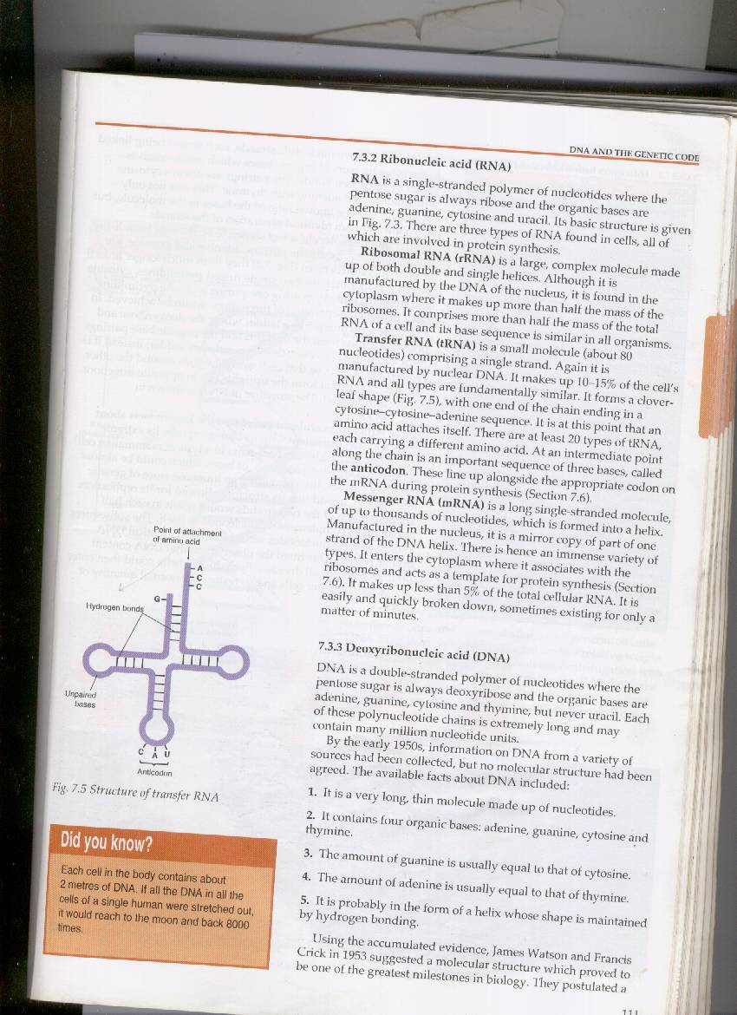tRNA possesses an important sequence of 3 bases called the anticodon. These line up a long side an appropriate codon on mRNA during protein synthesis
3. Messenger RNA (mRNA)
This is a single stranded molecule of up thousands of nucleotides formed on a single strand of DNA by a process known as transcription. In formation of mRNA one strand of DNA is used.
mRNA nucleotides are attracted to DNA strand according to the base pairing rule and link up to form mRNA polynucleotide strand under the influence of enzyme RNA polymerase
Base sequence of mRNA is complementary copy of the DNA template strand
It varies in length depending on the length of the peptide chain for which it codes. mRNA is not stable and it exists for a short time in cells.
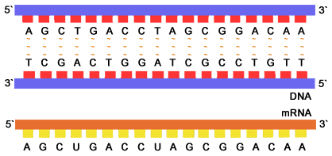
Differences between DNA and RNA
RNA | DNA
Is a single stranded polynucleotide chain | Is a double stranded polynucleotide chain
Pentose sugar is ribose | Pentose sugar is deoxyribose
Organic bases present are A G C and U | Organic bases present are A G C and T
3 basic forms of RNA | Only one basic form
Small molecule of about 10,000 nucleotides | Large molecular of about millions of nucleotides
Manufactured in the nucleus but mainly found in the cytoplasm | Mainly present in the chromosomes found in the nucleus, also found in the mitochondria and chloroplast
Chemically less stable

The genetic code;
The genetic code is the set of rules by which information encoded in genetic material (DNA or mRNA sequences) is translated into proteins (amino acid sequences) by living cells.
The code defines how sequences of three nucleotides, called codons, specify which amino acid will be added next during protein synthesis
For example, according to the genetic code, Codon UUU specified the amino acid phenylalanine, codon AAA specified the amino acid lysine, and the codon CCC specified the amino acid proline etc.
There are 64 different codon combinations possible with a triplet codon of three nucleotides (the genetic code has 64 codons). All 64 codons are assigned to either an amino acid or a stop signal. If, for example, an RNA sequence UUUAAACCC is considered and the reading frame starts with the first U (by convention, 5' to 3'), there are three codons, namely, UUU, AAA, and CCC, each of which specifies one amino acid. Therefore, this 9 base mRNA sequence will be translated into an amino acid sequence that is three amino acids long

Start/stop codons
Translation starts with a chain initiation codon (start codon).. The most common start codon is AUG, which is read as methionine. Alternative start codons (depending on the organism), include "GUG" or "UUG"; these codons normally represent valine and leucine, respectively, but, as a start codon, they are translated as methionine while others such as UAA, UAG, UGA are known as nonsense codons or stop codons and donot code for amino acids but act as stop siginals for termination of the polypeptide chain.
Characteristics of the genetic code:
- Triplet of bases in the polynucleotide chain of DNA is the code for the incorporation of one amino acid into the polypeptide chain.
- Its universal; it’s the same triplets code for the same amino acids in all organisms
- Its degenerate; a given amino acid may be coded for by more than one codon. Eg Amino acids like arginine may be coded for by six different codons.
- Its non overlapping; for example mRNA sequence beginning with AUGAGCGCA is not read AUG/UGA/GAG/AGC/GCG/CG A but its read as AUG, AGC and GCA.
Protein synthesis
This is the process by which the different 20 types of amino acids are assembled into a polypeptide chain using information from DNA.
There are four main stages in the formation of a protein.
- Amino acid synthesis
- Transcription (formation of mRNA)
- Amino acid activation
- Translation.
Synthesis of Amino acids:
In plants the process of amino acid formation occurs in mitochondria and chloroplasts in a series of stages:
- Absorption of nitrates from the soil
- Reduction of these nitrates to amino group
- Combination of these nitrates with a carbohydrate skeleton
- Transfer of the amino acid from one carbohydrate skeleton to another in a process known as transamination. In this way, all the 20 amino acids can be provided.
Animals usually obtain amino acids from the food they ingest, although they have some capacity to synthesize their own non-essential amino acids. The remaining nine essential must be provided in the diet.
Transcription;
Is the mechanism by which the base sequence of a cistron of a DNA strand is converted into the complementary base sequence of mRNA. The histone coat protecting the DNA double helix in the region of the cistron is stripped away, exposing the polynucleotide sequences of the DNA molecule.
The double helix un winds by the breakage of the relatively weak hydrogen bonds between the bases of complementary strands exposing single strands of DNA. Only one strand is selected as the template for the formation of mRNA.
Each base along one strand (the selected strand) attracts its complementary RNA nucleotides, ie a free Guanine base on the DNA will attract RNA nucleotide with a cytosine base and Uracil will be attracted to adenine.
The enzyme RNA polymerase moves along the DNA adding one complementary RNA nucleotide at a time to the newly unwound portion of DNA. DNA thus acts as a template against which mRNA is constructed.
A number of mRNA molecules will formed before the RNA polymerase leaves the DNA, which closes reforming its double helix and the protective protein coat is added again.
Being to large to diffuse across nuclear membrane, mRNA leaves instead through the nuclear pores and carry the genetic code to the ribosomes.
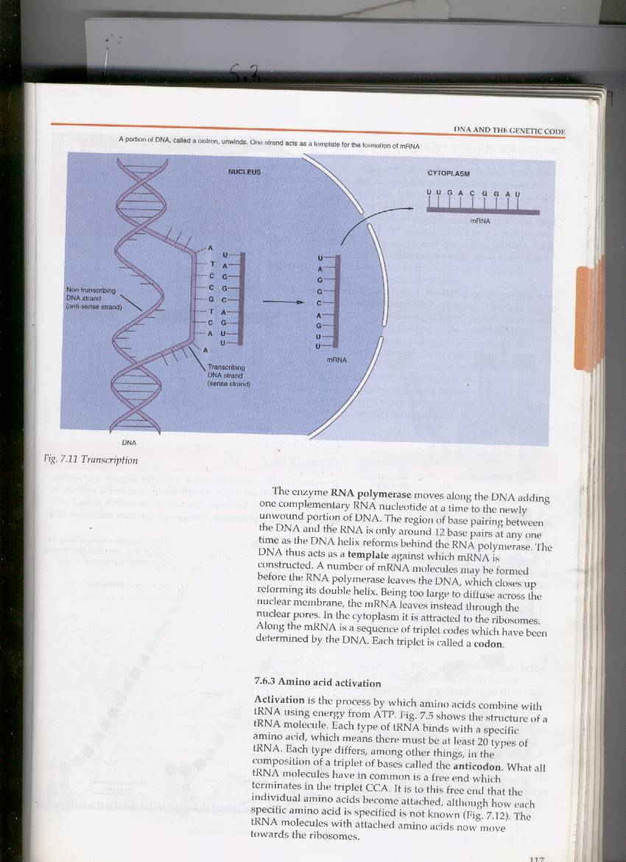

Amino acid activation;
Amino acid activation is the process by with amino acids combines with tRNA using energy from ATP.(see tRNA). The tRNA with attached amino acids now moves to the ribosomes.
Translation
Is the mechanism by which the triplet base sequences of mRNA molecules are converted into a specific sequence of amino acids in a polypeptide chain. This occurs on the ribosomes
Several ribosomes may become attached to a molecule of mRNA like beads on a string and the whole structure is known as a polysome. The advantage of such a complex is to allow several polypeptides to be synthesized simultaneously
The first codon of mRNA binds with the complementary Anticodon of tRNA molecule carrying the first amino acid usually methionine of the polypeptide being synthesized. The second codon then attracts a tRNA-amino acid complex showing the complementary anticodon. The ribosome acts as a frame work which holds the mRNA, tRNA-amino acid complex and the associated enzymes controlling the process together until the two amino acids form a peptide bond between each other.
Once they have been combined, the ribosome will move along the mRNA to the next codon and anticodon complex together until the third amino acid linked with the second. In this way a polypeptide chain is assembled by addition of one amino acid at a time.
Second and subsequent ribosomes may pass along the mRNA immediately behind the first there fore assembling many identical polypeptides simultaneously.
Once each amino acid is linked, the tRNA which carried it to mRNA is released back into the cytoplasm. Its again free to combine with its specific amino acid.
The ribosome continues to move along mRNA until it comes to a codon signaling stop. These nonsense/terminating codons are UAA, UAG and UGA. At this point the polypeptide chain in its primary structure leaves the ribosome and translation is complete.
As the polypeptide chains leave the ribosome they may immediately assume either the secondary, tertiary or quaternary structures.

